# Project Design Phase-II Technology Stack (Architecture & Stack)

|  |  |
| --- | --- |
| Date | 1 July 2025 |
| Team ID | LTVIP2025TMID44259 |
| Project Name | Pattern Sense: Classifying Fabric Patterns using  Deep Learning |
| Maximum Marks | 4 Marks |

Technical Architecture:

The Deliverable shall include the architectural diagram as below and the informa on as per the table1 & table 2

Reference: h ps://developer.ibm.com/pa erns/ai-powered-backend-system-for-order-processingduringpandemics/

|  |  |  |  |
| --- | --- | --- | --- |
| S.No | Component | Descrip on | Technology |
| 1. | User Interface | How user interacts with applica on (Web  Page) | HTML, CSS, Bootstrap,  Flask (Python) |
| 2. | Applica on Logic | Logic for a process in the applica on | Python |
| 3. | File Storage | File storage requirements | Stores predicted images in Local Filesystem |
| 4. | Machine Learning Model | Purpose of Machine Learning Model | VGG16 |

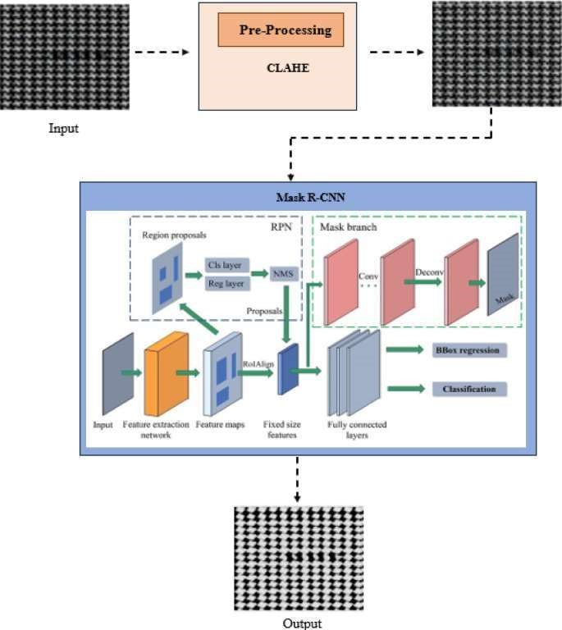

|  |  |  |  |
| --- | --- | --- | --- |
| 5. | Data | Data used to train the model | Dataset from Kaggle |

Table-1: Components & Technologies:

Table-2: Applica on Characteris cs:

|  |  |  |  |
| --- | --- | --- | --- |
| S.No | Characteris cs | Descrip on | Technology |
| 1. | Architecture | Layered and modular architecture separa ng UI, logic, model, and storage. | REST API, MVC Pa  ern,  Docker, Kubernetes |
| 2. | User Interface | Enables users to upload fabric images and view classifica on results. | React.js / Vue.js,  HTML5, CSS3 |
| 3. | API Interface | Facilitates image classifica on and feedback via RESTful endpoints. | Fast API / Flask, Swagger for documenta on |
| 4. | Security | Secures user data and API access. | HTTPS, JWT / API Keys, OAuth |

References: h ps://c4model.com/ h ps://developer.ibm.com/pa erns/online-order-processing-systemduring-pandemic/ h ps://www.ibm.com/cloud/architecture h ps://aws.amazon.com/architecture

h ps://medium.com/the-internal-startup/how-to-draw-useful-technical-architecture-

diagrams2d20c9fda90d